**Course**: CSC500_1

**Module & Assignment**: 7 & Critical Thinking Assignment

**Student**: Jegan Palaniyandi

### Creating Python Programs

#### The program should let the **user enter a course number** and then it should **display the course's room number, instructor, and meeting time**.

**Pseudocode**

# Pseudocode for Course Details Program

# Initialize three dictionaries room_dict, instructor_dict and meeting_time_dict as given in the problem statements as below.

room_dict = {'CSC101': 3004,

'CSC102': 4501,

'CSC103': 6755,

'NET110': 1244,

'COM241': 1411

}

instructor_dict = {'CSC101': 'Haynes',

'CSC102': 'Alvarado',

'CSC103': 'Rich',

'NET110': 'Burke',

'COM241': 'Lee'

}

meeting_time_dict = {'CSC101': '8:00 a.m.',

'CSC102': '9:00 a.m.',

'CSC103': '10:00 a.m.',

'NET110': '11:00 a.m.',

'COM241': '1:00 p.m.'

}

# Function to display course details

function course_details():

# Get user input for course number

input_prompt("Enter a course number --> ")

course_number = read_input()

# Check if course number exists in dictionaries

if course_number in room_dict:

room_number = room_dict[course_number]

instructor = instructor_dict[course_number]

meeting_time = meeting_time_dict[course_number]

# Display course information

output("Course: " + course_number)

output("Room Number: " + room_number)

output("Instructor: " + instructor)

output("Meeting Time: " + meeting_time)

else:

output("Course '" + course_number + "' not found. Please check the course number.")

# Main program

if __name__ == "__main__":

call course_details()

#### **Code**

def course_details():

*"""*

*This function will prompt the user for course number*

*and on submission, it will print the course number,*

*room number, instructor and Meeting time.*

*:return:*

*"""*

# Dictionaries containing course information

room_dict = {'CSC101': 3004,

'CSC102': 4501,

'CSC103': 6755,

'NET110': 1244,

'COM241': 1411

}

instructor_dict = {'CSC101': 'Haynes',

'CSC102': 'Alvarado',

'CSC103': 'Rich',

'NET110': 'Burke',

'COM241': 'Lee'

}

meeting_time_dict = {'CSC101': '8:00 a.m.',

'CSC102': '9:00 a.m.',

'CSC103': '10:00 a.m.',

'NET110': '11:00 a.m.',

'COM241': '1:00 p.m.'

}

# Get user input for course number

course_number = input("Enter a course number --> ")

# Look up information based on the course number

if course_number in room_dict:

room_number = room_dict[course_number]

instructor = instructor_dict[course_number]

meeting_time = meeting_time_dict[course_number]

# Display the information

print(f"Course: {course_number}")

print(f"Room Number: {room_number}")

print(f"Instructor: {instructor}")

print(f"Meeting Time: {meeting_time}")

else:

print(f"Course '{course_number}' not found. Please check the course number.")

if __name__ == "__main__":

course_details()

**Output**

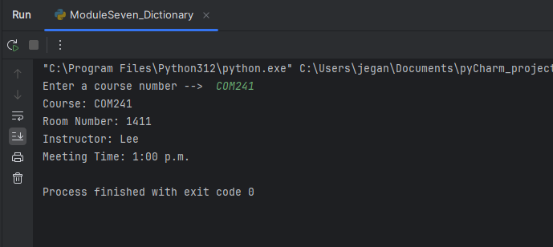

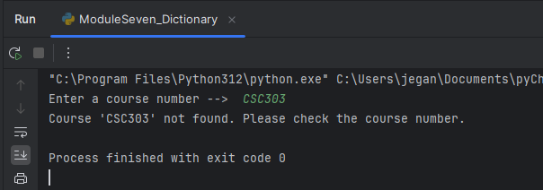

**GitHub Repository**

[**CSC500/moduleSeven at main · jeganpalaniyandi/CSC500 (github.com)**](https://github.com/jeganpalaniyandi/CSC500/tree/main/moduleSeven)